PENN STATE HUB-ROBESON CENTER

CHARLES M. SCHWAB AUDITORIUM

The Charles M. Schwab Auditorium is located on Pollock Road, on the University Park Campus of The Pennsylvania State University. University Park, Pennsylvania is located in the middle of the state, adjacent to the Borough of State College, at the convergence of U.S. Route 322, U.S. Route 220 and PA Route 26, just south of Interstate 80.

The University can be easily accessed from Interstate 80, by following either Route 322 East from the Woodland exit or Interstate 99/Route 220 South from the Bellefonte exit. Access from points south and east is via Route 322 West from the Harrisburg area, and access from points south and west is via Route 220 North from the Altoona area.

State College is serviced by air travel at the University Park Airport – SCE, via commuter aircraft US Airways Express, United Express, and Delta Express. The airport is approximately four miles from State College.

The information provided on the following pages has been prepared by members of the HUB-Robeson Center staff to answer the majority of your questions concerning the facility in which you will be performing during your stay at Penn State. You may also wish to visit our website at www.studentaffairs.psu.edu/hub/eventmanagement

If you have other questions, our primary point of contact for all events is Michael Blake, 814-867-4983. If he is unable to help you, he will direct your call appropriately. The list below includes contact information for other members of our staff. Please feel free to contact any of them for assistance. Regular office hours are Monday through Friday, from 9AM to 5PM.

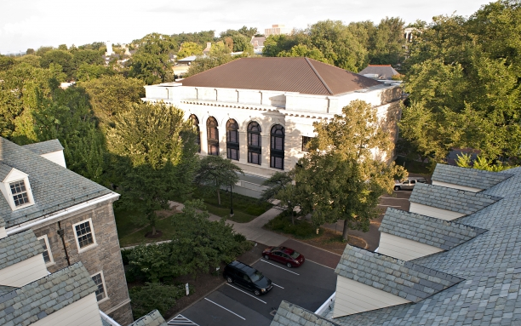
Reservations and Technical Management:
Michael Blake mcb29@psu.edu 814-867-4983
Production Manager

Jenna Campbell jnc5300@psu.edu 814-863-9318
Assistant Production Manager

We look forward to meeting you and doing everything possible to ensure a successful and pleasant event at The Pennsylvania State University.

PENN STATE HUB-ROBESON CENTER

CHARLES M. SCHWAB AUDITORIUM

Technical Information

TABLE OF CONTENTS

General Information 3

Seating Charts 4

Orchestra Level 4
Balcony Level 5

Loading Facilities 6

Stage Dimensions 7

Stage Rigging 8

Batten Locations 8
Stage Curtains 9

Stage Floor and Equipment 9

Electrics 10

Lighting Inventory 10

Sound System 11

Sound Inventory 11

Video Projection 12

Dressing Rooms 13

GENERAL INFORMATION

Penn State is an OSHA-compliant university.

The Charles M. Schwab Auditorium is an 894 seat, Renaissance style proscenium stage theatre which presents music, drama, and dance programs by nationally and internationally recognized performers in a theatre/concert hall setting. Note: Some balcony seating offers obstructed views. There are 730 seats that offer unobstructed views of the stage.

Production Manager: Michael Blake
Production Office Phone: (814) 867-4983

Email: mcb29@psu.edu

Assistant Production Manager: Jenna Campbell
Production Office Phone: (814) 863-9318

Email: jnc5300@psu.edu

Crew Personnel: The Auditorium is staffed by a paid student and non-student crew who work all the events presented in our facilities under the supervision of the Production Manager.

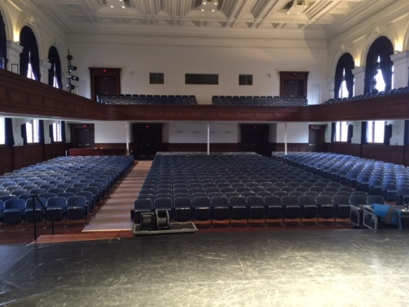
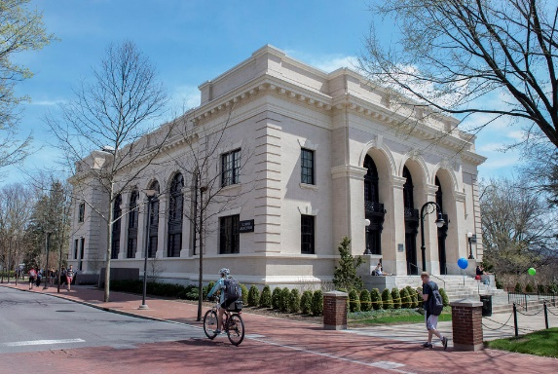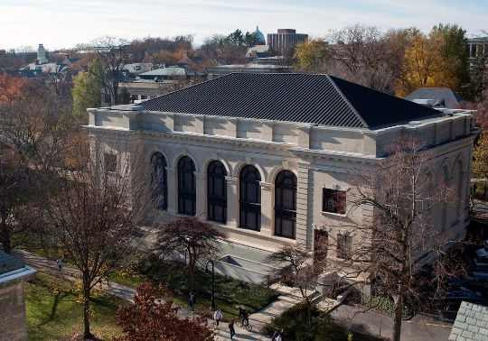
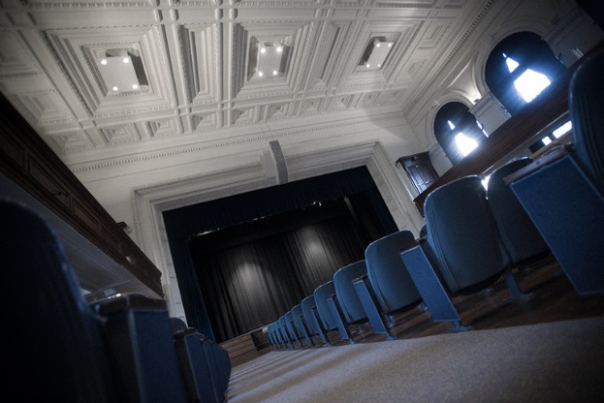
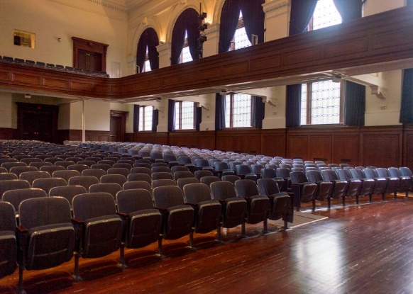

SEATING CHARTS

Schwab Auditorium
Orchestra Level

SEATING CHARTS

Schwab Auditorium
Balcony Level
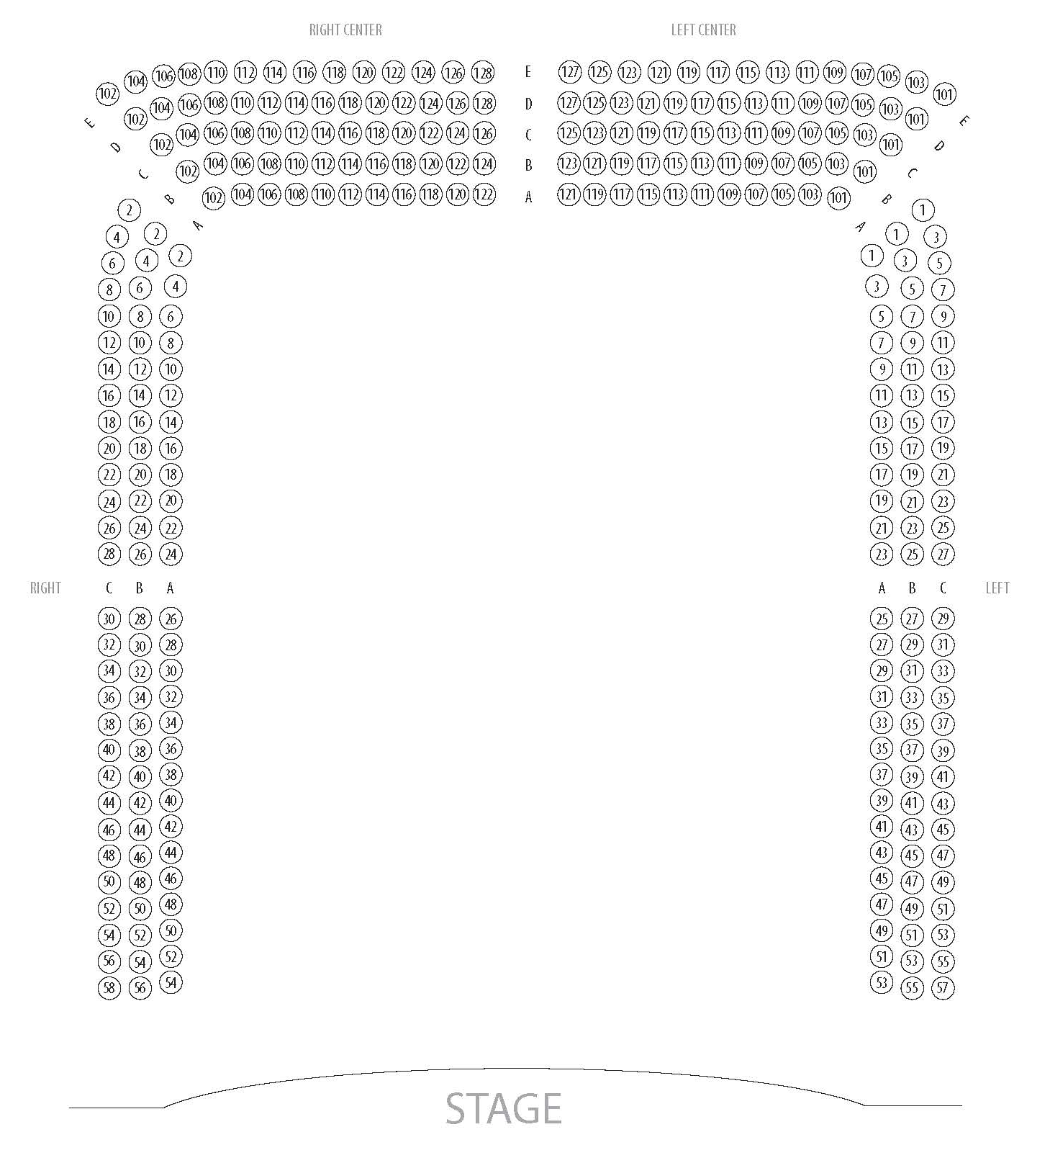

LOADING FACILITIES
There are no loading docks in the traditional sense. All load in options lead to house level in front of stage. The stage is 32 inches above house level. The house does not have truck ramps of any kind.

Option #1: There is one small shared space at the rear SL entrance for single vehicle. The loading space cannot accommodate vehicles larger than 26’ long. Unloading must be at right angle up approximately 4’ of concrete steps.
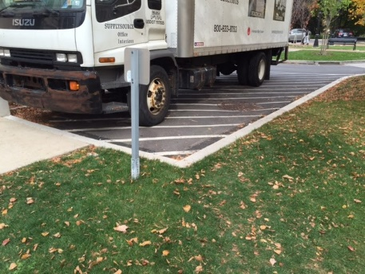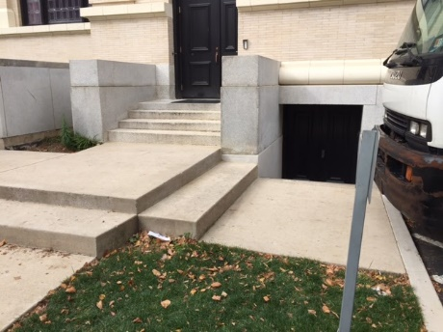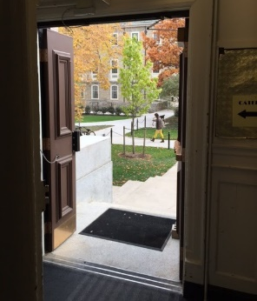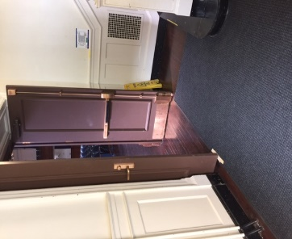
Rear parking lot loading spot. Steps to Stage Door entrance. 44” wide Stage Door 60” wide doorway into
at tightest point. auditorium, with corners.

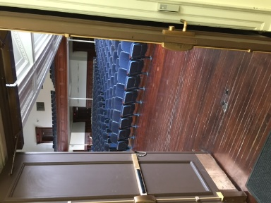
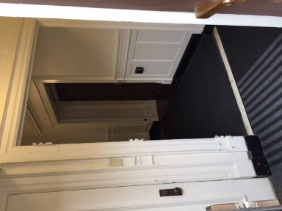
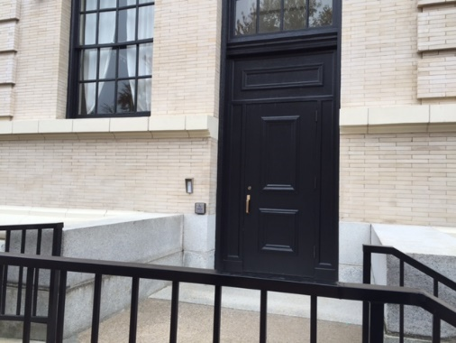
Option #2: Vehicle can unload on Pollock Road at the rear SR entrance. Unloading must be at right angle up approximately 4’ of elevation, via a 37” wide ramp. This entrance will accommodate at 9’ grand piano, shipped sideways on a piano board.
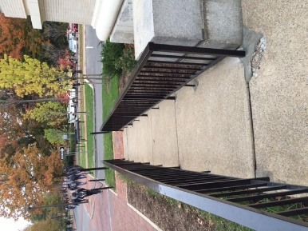
37” wide ADA ramp. 37” wide ADA door at tightest point. 44” wide corner 60” wide doorway into
auditorium

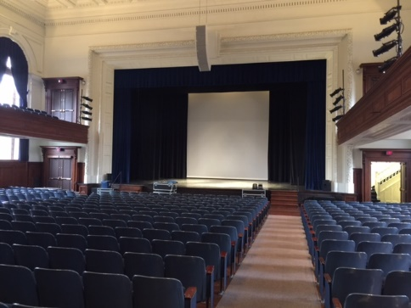
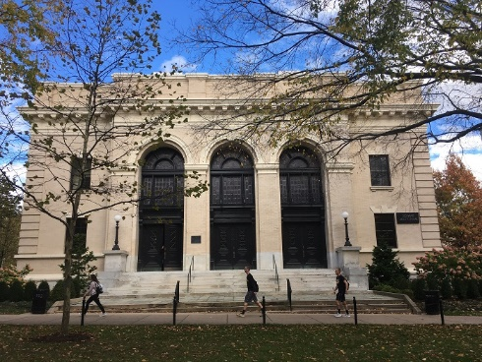
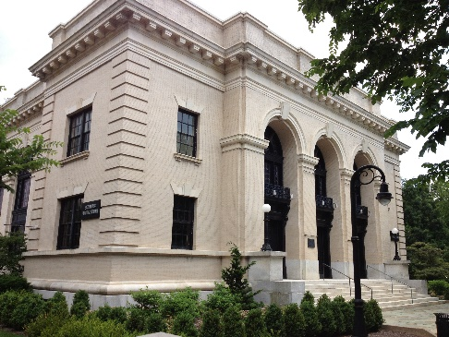
Option #3: Vehicle unloads on Pollock Road at the front entrance. Unloading must be up approximately 6’ of elevation of front steps.

STAGE DIMENSIONS

Proscenium opening height: 23'-6" tall
Proscenium opening width – between plaster: 42'-8" wide
Proscenium opening width – between Grand Main Drape: 36’-0” wide (maximum)

Height of stage from audience: 2'-8" tall

Stage width from wall to wall: 46'-8" wide
Stage width between the side masking draperies 40’-4” wide
Stage width between the side leg curtains 33’-0” wide

Stage depth from plaster line to curved downstage apron lip: 5'-8" deep (max. in center)
Stage depth from plaster line to Split Rear Drape: 17'-0" deep
Stage depth from plaster line to last upstage batten (CYC) 18’-0” deep
Stage depth from plaster line to upstage wall 22’-6” deep
The stage is raked 6” rake over 20’ from upstage to downstage.

There is access from Backstage to the Front of House from Stage Left through the basement. There is no basement access from Stage Right. A 4’ deep crossover is located upstage, behind a Split Rear Drape and Cyclorama.

STAGE RIGGING
Schwab does not have a grid or fly system. The stage house has (7x) total line sets on ETC Prodigy P1 fixed speed electric hoists,
each with 38’-0” long battens of 1-1/2” Schedule-40 pipe.
- (4x) general purpose support battens, with an 800# capacity.
- (3x) stage electrics hoists, each with cable management and a 1300# capacity. These normally carrying a rep plot.
Hoist controller panel is located stage right. Only the house is permitted to operate the electric hoist system.
Schwab rigging may only be used to support scenery and lighting fixtures. Additional hanging points are not available.

BATTEN LOCATIONS

DISTANCE: SET #: HOUSE HANG: COMMENTS:
0'-0" Plaster line
0'-7" 1 Grand Main Teaser Blue – dead hung – cannot be removed
1'-0" 2 Grand Main Drape Blue – dead hung traveler – cannot be removed
2’-6" 3 First Electric Wire way w/20 circuits
4’-10" 4 General Purpose Pipe #2
7’-2”" 5 General Purpose Pipe #3
9'-4" 6 Second Electric Wire way w/20 circuits
11'-4" 7 General Purpose Pipe #5
13'-4" Motorized Projection Screen Dead hung roller screen – cannot be removed
15'-4" 8 Third Electric Wire way w/18 circuits
17'-0" 9 Split Rear Drape Black – Dead Hung Traveler – cannot be removed
18'-0" 10 Cyclorama Pipe #7 Cyc – 30’ wide max viewable – cannot be removed
STAGE CURTAINS
The Grand Main Drape – A Blue, dead hung traveler, that is located 1’-0” upstage of the plaster line.
The operating position is down stage left.
The Split Rear Drape – A Black, dead hung traveler, that is located 16’-0” upstage of the Grand Main Drape.
The operating position is up stage left.
The Cyclorama – There is natural muslin cyclorama, located 17’-0” upstage of the Grand Main Drape on an electric hoist.
The maximum viewable dimensions of the cyclorama: 22’-0” tall by 30’0” wide.
The Side Masking Curtains – There is 16’-0” of side masking black curtains on a traveler track on each side the stage.
There are (3x) panels each side, that can be adjusted to allow for entrances.
Supplemental Drapery – The house has a collection of black leg curtains available for masking
- 21'-0" tall by 8'-0" wide
- 17'-0" tall by 8'-0" wide

STAGE FLOOR

The stage floor is hardwood (oak) – finished in black with ROSCO Tough Prime stage paint.
STAGE RAKE: The stage is on a 6" rake over 20' upstage from the plaster line.
There are no trap doors and the stage is not waxed or polished.
Approved tape may be used to lay ground cloths, dance floors, spike marks, etc.
Lag screws, stage screws, and/or drywall screws of any kind are not permitted and may not be used in the floor.

STAGE EQUIPMENT
1 each 25’ “Genie” personnel lift
1 each 10’ step ladder,
1 each 8’ step ladder
1 each 6’ step ladder
1 each hand truck
2 each 4-wheel dolly

DANCE FLOOR: The House has a Rosco Adagio Tour dance floor, with a matte black finish.
- Dance floor area: 36'-0" wide x 20'-0" deep.
STAGE RISERS: (4x) Wenger StageTek 3’ x 8’ Risers, with black tops and leg options for 8”, 16”, and 24” high.
Choral Risers are available upon request.

FOLDING CHAIRS: (36x) Black folding chairs for musician and general use.
MUSIC STANDS: (24x) Music stands available for use and (24x) clip lights for music stand illumination.
LECTERNS: (2x) Victoria full size, wooden lecterns available for use.

ELECTRICS AND LIGHTING

HOUSE LIGHTING: ETC Unison - House lighting is via an architectural lighting system, independent of the stage lighting
system, although they may also be controlled by the stage lighting control console.
ETC Sensor - (14x) D20AF dimmers dedicated to the house lighting system
LIGHTING CONSOLE: ETC Ion - The lighting console has fader wings to support up to 60 Faders and 6144 outputs.
It is located at the rear orchestra level on the house right side of the auditorium.
STAGE LIGHTING: ETC Sensor - (96x) D20AF (2.4kW) dimmers available for the stage lighting system. The stage
lighting system has numerous R20 relay modules in place for intelligent lighting use.
FOH POSITIONS: The auditorium (36x) 20amp circuits dedicated to FOH lighting positions
- FOH Coves: (3x) ceiling lighting bays with (4x) 20amp stage Pin circuits in each
The coves provide a 45º angle of light at the Plaster Line.
- FOH Balcony Booms: (4x) positions, two on each side of the house, along the balcony
rail. (24x) 20amp circuits total.
ONSTAGE POSITIONS: There are (3x) battens on electric hoists, with electrical wire-ways onstage. (See page 8 for locations)
- 1st Electric: (20x) 20amp stage pin circuits and 2 work light circuits
- 2nd Electric: (10x) 20amp stage pin circuits and 2 work light circuits
- 3rd Electric: (16x) 20amp stage pin circuits – circuits shared with backstage pockets
- Backstage Pockets: (16x) 20amp circuits total – circuits shared with the 3rd Electric.

LIGHTING FIXTURE INVENTORY: Please contact Production Management for most up-to-date rep plot and inventory.
MFG. Model No. Type Wattage Quantity
ETC Source4 Series 2 Daylight HD LED-ERS 300 28
ETC Source4 Lustr+ LED-ERS 240 20
ETC Selador Desire D40 LED Wash 240 25
ETC Selador Desire D22 LED Wash 120 16
Chauvet Rogue R2 Wash Moving Head LED 339 24
Chauvet Ovation C-640FC LED Cyc 175 10
ADDITIONAL LIGHTING: The house can assist with obtaining additional rental lighting equipment. Please contact Production Management for availability and rates

FIXTURE ACCESSORIES: The house stocks a selection of EDLT for Source4 fixtures: 19º, 26º, 36º, and 50º.
The house stocks a selection of gobo templates, primarily breakups patterns.
FOLLOW SPOTS: (2x) Lycian Midget HP 1209 follow spots, which operate from the projection booth.
ONSTAGE BOOMS: (4x) boom bases and 1½” I.D. boom pipe that is 8’ in height, as well as side arms and dropdowns. (4x) 12” box truss – 8’ and (2x) 12” box truss – 5’ available with bases for booms.

COMPANT SWITCH: The company switch is 100 amps, 3 phase-5 wire Cam-Lok panel, with Female, J-Series receptacles.
It is located below the stage, directly accessible through a small hatch located offstage left.
SOUND SYSTEM

FOH MIXING CONSOLE: Yamaha QL5 – 64 mono+8 stereo channel Digital Mixing Console. Permanently located at the rear
of the orchestra level on the house right side of the auditorium, in an open area adjacent to the house
right center aisle. The system operator has an unimpeded view of the stage and a clear line of sight to
the house loudspeaker system.

SNAKE LINES: (48x) Analog Mic Lines from stage, with (16x) Analog Returns
- (24x) Mic Lines and (8x) Returns Stage Right.
- (16x) Mic Lines and (4x) Returns Stage Left
- (8x) Mic Lines and (4x) Returns Front of Stage
(1x) Yamaha Rio3224-D2 Digital Snake (32x16).
FOH LOUDSPEAKERS: Center Mono Array – (5x) Electro-Voice EVA-2082 dual-element line-array modules suspended on
center line, above the proscenium. The house main array cannot be removed.
Front Fill Speakers – (4x) Electro-Voice EVU-2082/95 speakers on the front lip of the stage.
Subwoofers – (2x) Electro-Voice QRX-218S dual 18 subwoofers on the floor in front of the stage.
STAGE MONITORS: There are (4x) amplified mixes available and additional non-amplified mixes, via auxiliary sends from
the house sound console.
- (8x) Electro-Voice ELX112 stage monitors
- (2x) Electro-Voice ELX112P powered stage monitors
- (4x) Electro-Voice EVU-1082 compact stage monitors.
- (2x) Electro-Voice ELX118P powered subwoofers

WIRED MICROPHONE INVENTORY: Please contact Production Management for most up-to-date inventory.
Shure: (18x) SM58 (2x) Beta 52A (8x) KSM32 (6x) Beta 87C (5x) MX393/C
(10x) SM57 (1x) Beta 91 (7x) Beta 98AMP (1x) Super 55 (4x) MX202/C
AKG: (1x) D112 (4x) C3000
Audio-Technica: (6x) AT4041 (2x) AT2020 (12x) AT2021 (2x) U853
(1x) AT4054 (1x) AT2010 (1x) AT410
Sennheiser: (2x) e609 (7x) e608 (3x) e604 (1x) e602 Radial: (2x) JDI (2x) J48 (2x) PZ-DI (1x) USB-Pro
Countryman: (8x) Type 85 (5x) Type 85s
Whirlwind: (3x) pcDI

WIRELESS MICROPHONE INVENTORY: (24x) Shure ULXD Wireless Microphone Systems – H50 Band.
(24x) ULXD2/B87C condenser handheld transmitters (SM58 Capsules available on request)
(24x) ULXD1 bodypack transmitters - fitted with a selection of either: Countryman B3 bodymics
Audio-Technica BP894 headworn microphones
INTERCOM: The House has single channel Clear-Com user stations available at technical positions and Telex BTR-800 Wireless
Intercom available for production use.

VIDEO PROJECTION
There is a dedicated space for projection equipment in the center of the projection booth located at the rear of the balcony level.
Distance from projection booth to the stage is 88 feet. The house projector cannot be moved.
VIDEO PROJECTOR: Panasonic PT-DZ16k2U 3-Chip DLP, 16,000 lumens projector. The projector can be fitted with either:
- Panasonic ET-D75LE30 – 2.7-5.2:1 Zoom Lens
- Panasonic ET-D75LE40 – 5.1-8.2:1 Zoom Lens
VIDEO SWITCHING: Extron DTP CrossPoint 84 4k Series presentation matrix switching. Remote HDMI inputs to the
Switching system are available on stage left, the FOH mix site, and in the projection booth, via Extron
DTP transmitters and receivers.
Roland V-8HD video switcher is available for additional switching capabilities.

PROJECTION SCREEN: There are a few options for projection surfaces
- (1x) Draper Stage Screen – truss frame screen measuring 16 feet wide by 9 feet tall is available for use and can be suspended from one of the ETC Prodigy P1 Line Sets..
- (1x) Da-Lite Motorized Scenic Roller – measuring 28’ wide by 21’ tall that is mounted
13’-4” upstage of the plaster line.
- (1x) Cyclorama that can also be used as a projection surface, allowing for a larger viewing surface.

CONFIDENCE MONITORS: There are (2x) Sony 46” flat panel monitors on Chief PFQ monitor carts that can receive feeds from
the switching system.

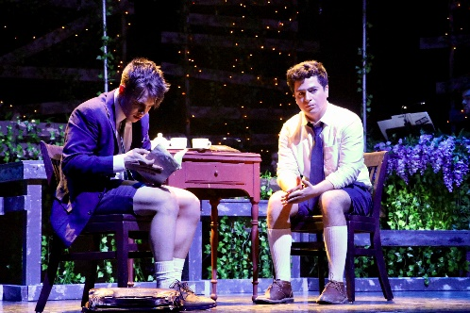
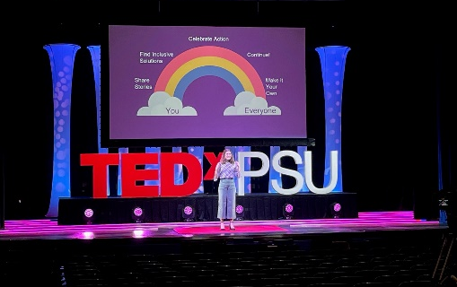
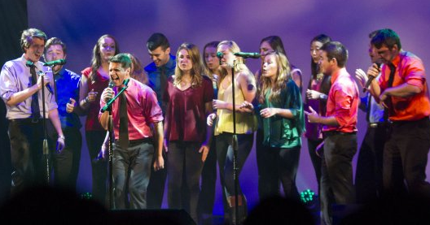
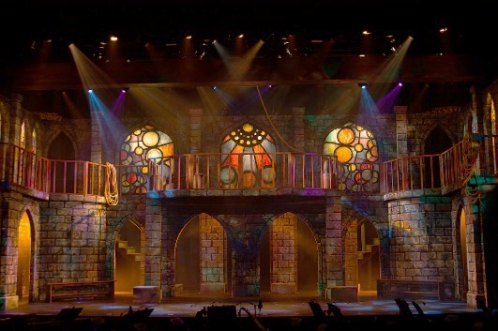

DRESSING ROOMS

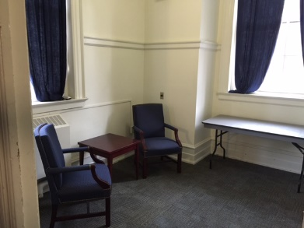
pPRINCIPAL DRESSING ROOM: There is (1x) small principal dressing room at stage level, located directly off stage left. It has a capacity for 1 or 2 performers, is carpeted, contains limited furnishings, mirrors, and a small private restroom with toilet and sink. This space can also be cleared of furniture and utilized as a quick change and/or prop staging area. The dressing room has audio monitoring of the house sound system.

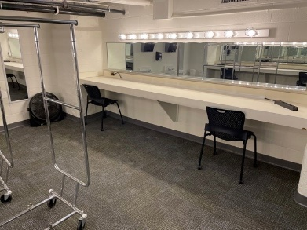
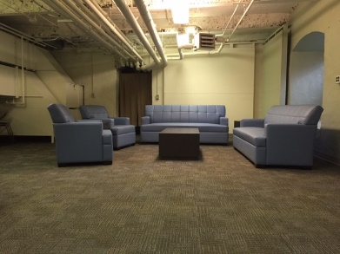
CHORUS DRESSING ROOMS: There are (2x) chorus dressing rooms, located in the basement, one of which will hold 12-14 performers and the other 8-10 performers. Each room is carpeted, and contains tables, chairs, mirrors, lights, clothing racks, and sinks. These rooms also have audio monitoring from the main sound system. The restroom facilities are located at the end of the hall and are shared with the audience. There are no shower facilities in the building. No elevator access is available. Basement access from stage is via stairs stage left only. There is basement room access from the front lobby as well.

GREENROOM: There is a furnished greenroom area located in the basement, directly below the stage which is available for use by the performers. The greenroom has both video and audio monitoring from the stage. The restroom facilities are located at the end of the hall and are shared with the audience. No elevator access is available. Basement access from stage is via stairs stage left only.
The auditorium does not contain a washer or dryer. An iron and ironing board are available for use.

ORCHESTRA LOFT

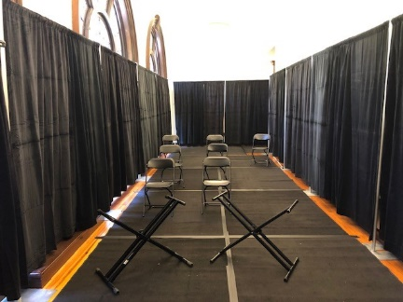
ORCHESTRA LOFT: There is a remote orchestra loft on the second floor, behind the projection booth. The space is 38’ long by 12’ wide. The orchestra can either be reinforced through the sound system via individual or area mics. The loft receives a camera feed of the stage and the conductor can be shown on downstage confidence monitors for the cast. Orchestra can receive headphone monitor mixes from the sound console.
FOLDING CHAIRS: (20x) Black folding chairs for musicians
MUSIC STANDS: (20x) Music stands available for use
MONITORING: (20x) Behringer P1 Headphone stations
DIGITAL PIANO: (1x) Yamaha CP300 Digital Stage Piano

